CHAPTER 4

PRESENTATION, ANALYSIS, AND INTERPRETATION OF RESULTS

After through evaluation by I.T experts and repondents, the following are the results bassed on the survey.
CRITERIA | MEAN | VERBAL ENTERPRETATION
How functional is our system in terms of displaying the total number of registered residents? | 4.32 | Strongly Functional
How functional is our system in terms of displaying the total number of requests? | 4.15 | Strongly Functional
How functional is our system in terms of displaying the total number of pending requests? | 4.18 | Strongly Functional
How functional is our system in terms of displaying the total number of approved requests? | 4.06 | Strongly Functional
How functional is our system in terms of displaying the total number of monthly requests? | 4.03 | Strongly Functional
How functional is our system in terms of displaying requests by certificate or clearance type? | 4.03 | Strongly Functional
How functional is our system in terms of displaying recent requests? | 4.21 | Strongly Functional
TOTAL WEIGHTED MEAN | 4.14 | Strongly Functional
Table 1. In terms of displaying Admin dashboard information.
Table 1 shows the evaluation of the dashboard functionality reveals that the system is strongly functional overall, with a total weighted mean of 4.14. Among the criteria, the highest score was 4.32 for displaying the total number of registered residents, showing excellent performance in this area. Displaying recent requests also performed well with a mean of 4.21, followed by pending requests (4.18) and total requests (4.15). Approved requests scored 4.06, while both monthly requests and requests by certificate/clearance type received the lowest but still strong mean of 4.03. These results suggest that the dashboard is reliable and effective in presenting essential data, though slight improvements could be made in displaying monthly and categorized requests. Overall, the findings confirm that the dashboard provides clear, organized, and accessible information that supports efficient monitoring and decision-making in barangay operations.

Figure . In terms of displaying administrative dashboard information.
Figure shows the assessment of the administrative dashboard demonstrates that the system is strongly functional in presenting and summarizing key operational data. The dashboard effectively displays the number of new, total, pending, and approved requests, as well as the total number of residents, providing a clear overview of barangay activities. Visual elements such as bar charts for monthly requests and a donut chart for requests by type enhance data interpretation, while the recent requests table ensures transparency and accessibility of current transactions. These features confirm that the dashboard is reliable and efficient in supporting monitoring, reporting, and decision-making processes, making it a valuable tool for managing barangay operations.
CRITERIA | MEAN | VERBAL ENTERPRETATION
How functional is our system in terms of creating, viewing, updating, archiving, and restoring resident records? | 4.38 | Strongly Functional
How functional is our system in terms of managing certificate and clearance types, including fees, processing days, and requirements? | 4.38 | Strongly Functional
How functional is our system in terms of creating, viewing, updating, suspending, archiving, and restoring user accounts? | 4.39 | Strongly Functional
How functional is our system in terms of creating, viewing, updating, and archiving barangay officials' records? | 4.39 | Strongly Functional
How functional is our system in terms of viewing requests, updating their status, and archiving completed or cancelled requests? | 4.39 | Strongly Functional
How functional is our system in terms of adding summons or blotter requests and updating their status? | 4.28 | Strongly Functional
TOTAL WEIGHTED MEAN | 4.37 | Strongly Functional

Table 1. In terms of displaying system functionality across core operations.
The table shows the evaluation results indicate that the system is strongly functional overall, with a total weighted mean of 4.37. Each criterion demonstrates high effectiveness: managing resident records and certificate/clearance types both scored 4.38, while user accounts, barangay officials’ records, and request tracking achieved the highest mean of 4.39, reflecting excellent performance in these areas. Handling summons and blotter requests received the lowest score of 4.28, though it still falls within the Strongly Functional range, suggesting only minor room for improvement. Overall, the findings confirm that the system is reliable, efficient, and capable of supporting barangay operations with robust functionality across its essential modules.

Figure . In terms of creating, viewing, updating, archiving, and restoring resident records.

Figure . shows the evaluation of the request management module shows that the system is highly functional in presenting and processing request information, with features such as displaying request numbers, names, dates, statuses, and detailed request information including payment records and certificate previews. The interface allows users to view request details efficiently, with options to preview certificates, print documents, mark requests as released, and record payments. This demonstrates that the system is not only capable of tracking and updating requests but also integrates financial transactions and document handling seamlessly. Overall, the findings suggest that the request management dashboard is strongly functional, providing clear, organized, and accessible information that supports effective administrative operations.

Figure . In terms of managing certificate and clearance types, including fees, processing days, and requirements.
Figure shows the evaluation of the certificate type management module shows that the system is strongly functional in handling and presenting certificate-related information. The interface allows administrators to edit and update certificate details such as name, category, fees, processing days, requirements, and descriptions, ensuring that all essential data is clearly defined and easily accessible. With options to update or cancel changes, and a structured list of certificate types with corresponding templates and requirements, the system provides flexibility and efficiency in managing official documents. Overall, this functionality supports accurate record-keeping and streamlined processing, confirming that the certificate type management feature is reliable and effective for barangay operations.

Figure . In terms of displaying resident management functionality.
Figure shows the evaluation of the resident management module shows that the system is strongly functional in handling resident records and account administration. The interface provides a clear table of resident details such as full name, gender, civil status, contact information, and purok, along with account status and action options. The inclusion of features like archiving residents ensures that administrators can deactivate accounts when necessary, while still retaining the ability to restore them later, which supports both flexibility and accountability. Overall, this functionality demonstrates that the system is reliable and efficient in managing resident data, offering organized access and control that strengthens barangay operations and record-keeping.

Figure . In terms of creating, viewing, updating, and archiving barangay officials' records.
The evaluation of the barangay officials’ management module shows that the system is strongly functional in organizing and maintaining officials’ records. The interface provides a structured list of officials with details such as names, positions, term start and end dates, status, and photos, ensuring transparency and accountability. The inclusion of editing features allows administrators to update information, archive records, or adjust sorting order, which supports efficient record-keeping and adaptability to changes in leadership. Overall, this functionality demonstrates that the system is reliable and effective in managing barangay officials’ data, contributing to organized governance and streamlined administrative processes.

Figure . In terms of viewing requests, updating their status, and archiving completed or cancelled requests.
Figure shows the evaluation of the request management module demonstrates that the system is strongly functional in handling and presenting detailed request information. The interface provides comprehensive data such as tracking numbers, resident names, contact details, transaction types, purposes, pickup options, and remarks, ensuring clarity and transparency in request processing. Additionally, integrated features like certificate preview, document printing, marking requests as released, archiving, and recording payments highlight the system’s efficiency in managing both administrative and financial aspects of barangay operations. Overall, this functionality confirms that the request management feature is reliable, organized, and effective in supporting streamlined service delivery.

Figure . In terms of adding summons or blotter requests and updating their status.
Figure shows the evaluation of the summons and blotter management module shows that the system is strongly functional in handling case records and hearing schedules. The interface provides detailed fields such as case number, status, nature of dispute, incident details, resolution summaries, and hearing history, ensuring that all essential information is properly documented and accessible. Features like updating case status, recording remarks, and scheduling future sessions highlight the system’s efficiency in supporting legal and disciplinary processes within the barangay. Overall, this functionality demonstrates that the system is reliable, organized, and effective in managing summons and blotter cases, contributing to transparent and structured community dispute resolution.
CRITERIA | MEAN | VERBAL ENTERPRETATION
How functional is our system in terms of generating and printing monthly transaction reports? | 4.24 | Strongly Functional
How functional is our system in terms of summarizing issued clearances and certificates, total transactions, total collections, and certificate types in monthly reports? | 4.09 | Strongly Functional
How functional is our system in terms of allowing residents to view the status of their requests? | 4.09 | Strongly Functional
TOTAL WEIGHTED MEAN | 4.12 | Strongly Functional

Table 3. In terms of displaying reporting and request status functionality.
The evaluation of the reporting and request status features shows that the system is strongly functional overall, with a total weighted mean of 4.12. Generating and printing monthly transaction reports received the highest score of 4.24, reflecting strong efficiency in producing official records. Summarizing issued clearances, certificates, transactions, collections, and certificate types in monthly reports scored 4.09, while allowing residents to view the status of their requests earned scores of 4.09 and 4.12, both indicating reliable performance. These results confirm that the system is effective in supporting transparency, accountability, and accessibility, ensuring that both administrators and residents can monitor transactions and request statuses with ease. Overall, the reporting and request status modules demonstrate dependable functionality that strengthens barangay operations.

Figure . In terms of generating and printing monthly transaction reports.
Figure shows the evaluation of the monthly transaction reporting feature shows that the system is strongly functional in generating and presenting official records of barangay activities. The interface provides a clear summary of total transactions, total collections, and report generation dates, alongside a detailed table of individual transactions with corresponding IDs, names, document types, statuses, and amounts. This structured presentation ensures transparency, accountability, and ease of monitoring financial and administrative activities. The inclusion of print preview options further enhances usability, allowing reports to be formally documented and shared. Overall, this functionality demonstrates that the system is reliable and efficient in producing accurate monthly transaction reports, supporting effective governance and record-keeping.

Figure . in terms of summarizing issued clearances and certificates, total transactions, total collections, and certificate types in monthly reports.

Figure . shows the evaluation of the financial and payroll reporting module shows that the system is strongly functional in organizing and presenting transaction data. The interface provides structured tables with employee names, identification numbers, departments, and amounts, along with summary sections for adjustments, deductions, and remarks. This ensures that payroll and financial records are transparent, accurate, and easy to monitor. By consolidating pay periods, pay dates, and detailed transaction information, the system supports accountability and efficient financial management. Overall, this functionality demonstrates that the reporting feature is reliable and effective in handling payroll and monthly transaction records, strengthening administrative and financial operations.

Figure . In terms of allowing residents to view the status of their requests.
Figure shows the evaluation of the request tracking module shows that the system is strongly functional in providing transparency and accessibility for residents. The interface allows users to input a tracking number and instantly view the status of their request, including details such as document type, requester’s name, date of request, payment amount, and progress stages. With clear indicators like “Submitted,” “Approved,” and “Released,” residents can easily monitor the progress of their applications without needing to visit the barangay office. This functionality enhances efficiency, accountability, and user satisfaction, confirming that the request tracking feature is reliable and effective in supporting digital service delivery.

CRITERIA | MEAN | VERBAL ENTERPRETATION
How functional is our system in terms of allowing users to access the platform through mobile devices? | 4.03 | Functional
How functional is our system in terms of providing convenient access to barangay services through the mobile application? | 4.03 | Functional
TOTAL WEIGHTED MEAN | 4.03 | Functional
Table 4. In terms of displaying mobile accessibility functionality.
Table 4 shows the evaluation of the mobile accessibility features shows that the system is functional overall, with a total weighted mean of 4.03. Both criteria—allowing users to access the platform through mobile devices (4.03) and providing convenient access to barangay services via the mobile application (4.03)—received the same score, indicating consistent performance. While these results confirm that the mobile platform is reliable and usable, they also suggest that there is room for enhancement to elevate the experience from Functional to Strongly Functional. Overall, the findings highlight that the mobile application successfully supports residents in accessing barangay services, but further improvements could strengthen convenience and efficiency.

Figure . In terms of displaying mobile application functionality.
Figure shows the evaluation of the mobile application interface shows that the system is functional in providing residents with digital access to barangay services. The app includes essential features such as login and registration forms, ensuring secure access, and a dashboard that presents available services like clearances, certificates, blotter, summons, and equipment borrowing. With a weighted mean of 4.03, the results confirm that the mobile platform reliably supports user access and service requests, though it remains at the Functional level rather than Strongly Functional. This suggests that while the mobile application is effective in extending convenience and accessibility, further enhancements—such as improved responsiveness, user experience design, or additional features—could elevate its performance and overall usability.
CRITERIA | MEAN | VERBAL ENTERPRETATION
How functional is our system in terms of sending real-time SMS updates about request statuses? | 4.03 | Strongly Funtional
How functional is our system in terms of sending SMS reminders to residents? | 4.09 | Strongly Funtional
How functional is our system in terms of sending important barangay announcements through SMS? | 4.12 | Strongly Funtional
TOTAL WEIGHTED MEAN | 4.08 | Strongly Funtional

Table 5. In terms of displaying SMS notification functionality.
Table 5 shows the evaluation of the SMS notification features shows that the system is strongly functional overall, with a total weighted mean of 4.08. Sending real-time SMS updates about request statuses scored 4.03, indicating reliable performance in keeping residents informed of their transactions. SMS reminders to residents received a slightly higher score of 4.09, reflecting effective support for timely follow-ups. The highest rating was 4.12 for sending important barangay announcements, highlighting the system’s strength in disseminating critical information quickly and efficiently. These results confirm that the SMS module enhances transparency, communication, and resident engagement, making it a valuable tool for strengthening barangay service delivery.

CRITERIA | MEAN | VERBAL INTERPRETATION
Functional Suitability | 4.31 | Strongly Funtional
Performance efficiency | 4.12 | Strongly Funtional
Compatibility | 4.56 | Strongly Funtional
Reliability | 4.01 | Strongly Funtional
Security | 4.12 | Strongly Funtional
Total weighted mean | 4.22 | Strongly Funtional
Table . In terms of Functional Suitability, Performance Efficiency, Compatibility, Reliability, and Security.
The results show that the system is rated Strongly Functional overall, with a total weighted mean of 4.22. Specifically, the system demonstrates strong functionality in functional suitability (4.31), performance efficiency (4.12), compatibility (4.56), reliability (4.01), and security (4.12). These findings confirm that the system performs consistently well across all core quality attributes, ensuring that it is suitable, efficient, compatible, reliable, and secure for student council operations and services.

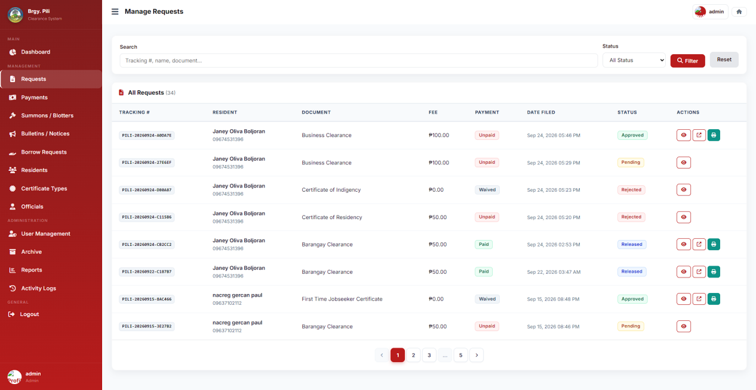
Figure . Software Best Quality Functions.
The figure shows the part of the system where document requests are efficiently managed and tracked. The interface provides a structured dashboard with clear categories such as tracking numbers, resident names, document types, fees, payment status, filing dates, and request outcomes (Approved, Pending, or Rejected). Action buttons allow administrators to view, edit, or delete entries, ensuring smooth workflow and accountability. This section highlights the system’s best functionality, as it integrates transparency, efficiency, and control in handling multiple requests, making it highly reliable for governance and administrative operations.

CRITERIA | MEAN | VERBAL INTERPRETATION
Ease of Use | 4.31 | Functional
Usefulness | 4.41 | Functional
Ease of Learning | 4.44 | Functional
Satisfaction | 4.31 | Functional
Total Weighted Mean | 4.37 | Functional
Table . In terms of displaying overall usability and user satisfaction.
Table shows the evaluation of the system’s usability and satisfaction shows that it is functional overall, with a total weighted mean of 4.37. Among the criteria, Ease of Learning received the highest score of 4.44, indicating that users find the system straightforward to understand and operate. Usefulness followed closely with 4.41, reflecting that the system effectively meets user needs and supports barangay services. Both Ease of Use and Satisfaction scored 4.31, showing consistent performance in user experience and overall contentment. These results confirm that the system is reliable and beneficial, though still rated at the Functional level, suggesting that further refinements in interface design and user engagement could elevate it to Strongly Functional. Overall, the findings highlight that the system successfully balances usability, usefulness, and satisfaction, making it a dependable tool for residents and administrators alike.
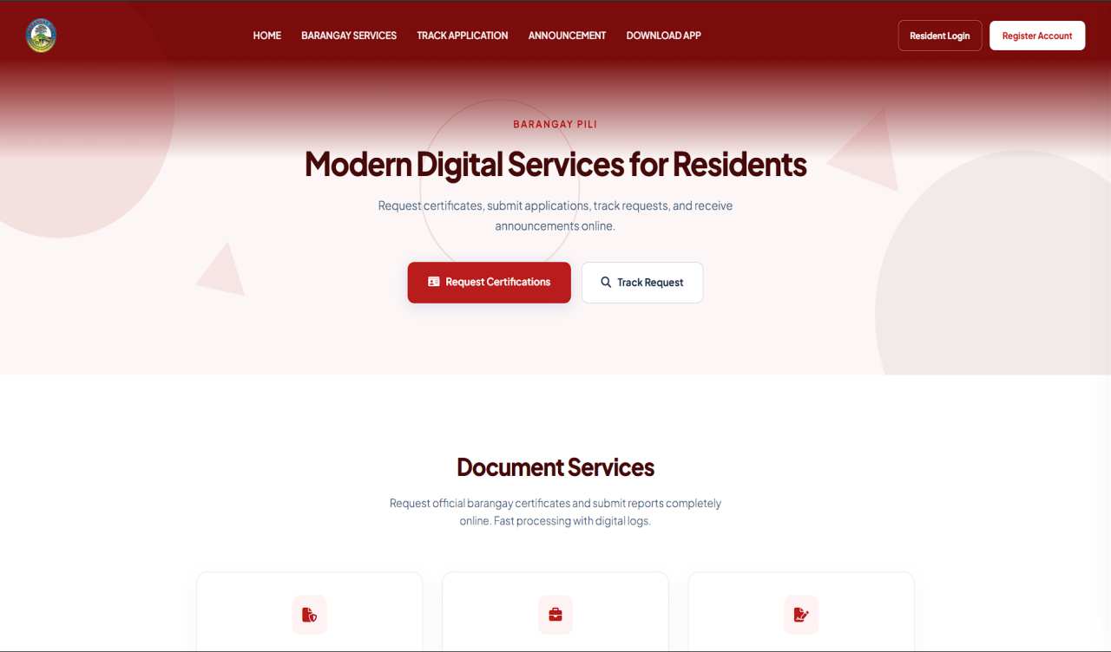

Figure . Software Usability
The figure above shows the functionality of the “A Web-Based Platform for Streamlined Clearance and Certificate Processing of Barangay Pili” displaying the landing page where the resident’s can access login and register portal and download mobile application for more features.

